In a war, children without a childhood
By Los Angeles TImes, adapted by Newsela staff on 05.21.14
Word Count 882
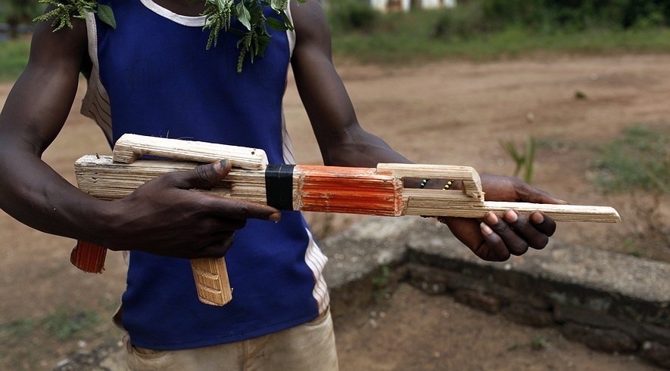
A former child soldier performed a skit about his life with the rebels when officials from the U.N. Children's Fund visited the Central African Republic in March 2014. His face is not pictured to protect his identity. During civil strife in the country, many children served as soldiers in the battles. Photo: Rick Loomis/Los Angeles Times/MCT
SIBUT, Central African Republic — At 14, Jordy isn't much taller than the gun he carried as a child soldier.
“It was a way to protect myself, and it was a way to survive,” said Jordy.
“I did a lot of bad things,” he said, eyes downcast, speaking about raiding peoples' homes. "I took people’s things by force.”
The conflict tearing the Central African Republic apart has turned neighbor against neighbor. For many, it has brought childhood to a halt.
Children have seen their parents killed and watched as boys and girls just like them were hurt. They have been forced to make decisions far beyond their years. Some took up arms with the same fighters who upended their lives or killed their relatives.

Soldiers And Slaves
Children have been used as game pieces in virtually every conflict in this country, one of the poorest in the world. When a rebel group known as the Seleka seized power a little more than a year ago, as many as 3,500 children marched with them. Other armed groups started fighting back and the number of child soldiers swelled to 6,000, UNICEF estimates.
Some, like Jordy, were handed guns, while other children were enslaved.
Children barely in their teens still accompany fighters along the rutted 100-mile road from Bangui, the capital, to Jordy's hometown, Sibut. Even by day, armed men threaten travelers from makeshift roadblocks. Other fighters march to Sibut with rifles and machetes slung over their shoulders and protective amulets draped around their necks.
The Seleka left behind nearly 400 children when they were pushed from power in January. Recently, the humanitarian organization UNICEF negotiated the release of more than 1,000 other children from the armed groups.
On a recent day, dozens of the children gathered on a shaded veranda in Sibut brought together by UNICEF.
Several of them appealed to visitors with shy, winsome smiles, but a few were angry, shouting that they needed help. A pregnant young girl was pushed forward. “See what they did?” a boy said of the rebels.
Not long ago, Charly had money, a rebel uniform that commanded fear, and an AK-47 he wasn’t afraid to use.
The thought of the return to his old life makes him sit rigid with anger, his eyes flashing.
“See the shoes I’m wearing?” the teenager snapped, pointing at a pair of dusty blue flipflops full of holes.

"A Gun In My Hand"
With the rebels, he had power, Charly said. “I had boots, a uniform and a gun in my hand.” Charly recalled the day, more than an year ago, when the rebels arrived.
He was 15, and he was selling soap, sugar and other goods from a market stall in Sibut. His father was dead, and his mother couldn’t support him.
The fighters streamed in on motorcycles and in pickup trucks, firing their guns, setting homes and businesses on fire.
“When they saw I was brave, and I could point out houses to rob, they accepted me,” he said. He was given a Kalashnikov assault rifle and sent on patrols around his hometown, his fear replaced by arrogance.
“Everyone saw me carrying an AK,” he said. When an old woman tried to curse Charly's grandmother, he shot her in the foot.
When the rebels continued their advance on Bangui, Jordy, Charly and other youths went with them. Some were forced to go, but others were drawn by the prospect of looting in the capital.
“When I saw them starting to kill people, that’s when I left,” Charly said.
Charly had a grandmother to take care of him, but many children don’t even know where their relatives are. Hundreds of thousands of people have fled their homes in the fighting, and humanitarian workers who are caring for some of the former fighters can spend months trying to locate the children’s families.
When families can be traced, they may be reluctant to take their sons back. Children who are used to carrying weapons find it hard to obey their parents.

A Colonel's "Wife"
Mireille was 14 when a rebel colonel spotted her last year and announced that he wanted to marry her.
“I said, ‘No, I’m still young,’” recalled the slender girl with intricately braided hair. She sat hunched on a bench, wringing her hands in her lap.
That night, the rebel colonel showed up at her home, and took her to a Seleka base, where he forced her to be his wife and gave her a new name, Kadija.
“I wanted to escape, but I couldn’t because everyone had weapons,” she said.
After several months, the colonel lost interest in Mireille and took other “wives,” including her older sister.
The reunification process has been especially difficult for the 78 girls freed by the Seleka, many of whom like Mireille, were sexually abused. Their families and communities often consider them tainted — or dirty because of the abuse they faced.
Many children still march with the fighters, but those who have left struggle to find a way forward.
Mireille said she’d like to go back to school, and Jordy said he would like to try farming. Charly, though, already been approached by militias eager to take advantage of his knowledge of the mainly Muslim Seleka.
“With a gun,” he said, “you always have money.”

Quiz
- Select the paragraph from the section “A Gun In My Hand” that explains why it may be difficult to even find the families of kids taken by the rebel groups.
- Which sentence describes a problem girls leaving or escaping from rebel groups might face?
  - “I said, ‘No, I’m still young,’” recalled the slender girl with intricately braided hair
  - Many children still march with the fighters, but those who have left struggle to find a way forward.
  - Their families and communities often consider them tainted — or dirty because of the abuse they faced.
  - “I wanted to escape, but I couldn’t because everyone had weapons,” she said.
- Read the sentence from the article.
Even by day, armed men threaten travelers from makeshift roadblocks.
What does “makeshift” suggest about the roadblocks?
  - The roadblocks are thrown together and permanent.
  - The roadblocks are manufactured and improvised.
  - The roadblocks are thrown together and temporary.
  - The roadblocks are manufactured and stopgap.
- Read the sentence from the article.
On a recent day, dozens of the children gathered on a shaded veranda in Sibut brought together by UNICEF.
Which selection from the sentence helps explain the meaning of the word “veranda”?
  - a recent day
  - dozens of children
  - gathered on
  - brought together

Answer Key
- Select the paragraph from the section “A Gun In My Hand” that explains why it may be difficult to even find the families of kids taken by the rebel groups.
Paragraph 22:
Charly had a grandmother to take care of him, but many children don’t even know where their relatives are. Hundreds of thousands of people have fled their homes in the fighting, and humanitarian workers who are caring for some of the former fighters can spend months trying to locate the children’s families.
- Which sentence describes a problem girls leaving or escaping from rebel groups might face?
    - “I said, ‘No, I’m still young,’” recalled the slender girl with intricately braided hair
    - Many children still march with the fighters, but those who have left struggle to find a way forward.
    - Their families and communities often consider them tainted — or dirty because of the abuse they faced.
    - “I wanted to escape, but I couldn’t because everyone had weapons,” she said.
- Read the sentence from the article.
Even by day, armed men threaten travelers from makeshift roadblocks.
What does “makeshift” suggest about the roadblocks?
    - The roadblocks are thrown together and permanent.
    - The roadblocks are manufactured and improvised.
    - The roadblocks are thrown together and temporary.
    - The roadblocks are manufactured and stopgap.
- Read the sentence from the article.
On a recent day, dozens of the children gathered on a shaded veranda in Sibut brought together by UNICEF.
Which selection from the sentence helps explain the meaning of the word “veranda”?
  - a recent day
  - dozens of children
  - gathered on
  - brought together

