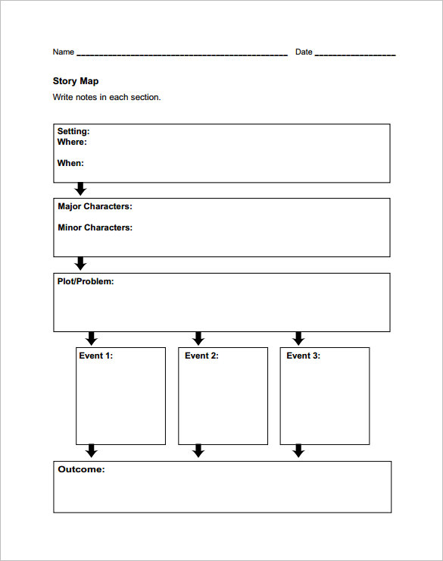
Figurative language
Directions: Incorporate the following figurative language elements in your children’s book. They must be underlined!
(5) Dialogue
(3) Imagery
(2) Metaphors
(2) Similes
(1) Idiom
(3) Onomatopoeias
(2) Personification
Theme – The last slide

Design requirements
- Pictures (clipart) or a background on each slide
- Transitions between each slide
- No more than 4-5 sentences on one slide- font size should be proportioned to picture(s) etc. on slide
- Moving clipart is optional (must be appropriate)
- First slide must include the title and author’s name (you)
- Second slide must introduce the exposition
- Last slide must present the theme of the narrative
- Maximum of 12 slides

