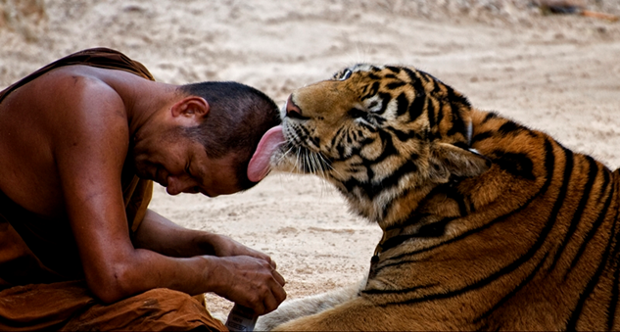

Name_________________________Caption____________________________________________________________________________________________________________________

Name_________________________Caption_________________________________________________________________________________________________________________

Name_________________________

Caption_________________________________________________________________________________________________________________