Grammar into the Day
The Alchemist
Name_________________________

Find nine corrections in the paragraph below:
people from all over the world have passed through this village, son said his father. “They come in search of new things, but when they leave they are vasically the same peeple they were when they arrived. they climb the mountain to see the castle, and they wind up thinkin that the past was better than what we have now they have blond hair, or dark skin, but vasically they’re the same as the people who right here.” (P. 11 The Alchemist)
Proofreader’s Marks:

Closing:

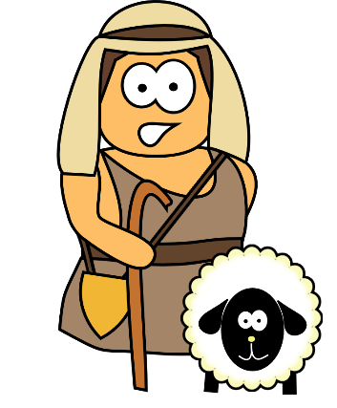
I believe ________________________________ because _________________. I am confused by __________________.

