Reading/Writing Intervention Week #2
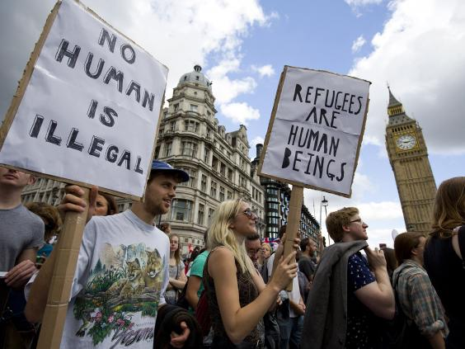
Name_____________________
7th Grade ELA Ms. Fronk

Readers Assignment

- Students will use the article Shattered Lives and guided notes to create a detailed refugee map with a key. The key must have at least 5 items. The map will portray the setup of a refugee camp. The map must also include 5 quotes which explain or support the layout and/or items found in a refugee camp.

Rubric=
Map…10 points
Key with 5 items…10 points
5 Quotes…15 points
Total…35 points

- Students will illustrate or design a symbol to represent something about daily life in a refugee camp. Students will explain in 3-5 sentences why the symbol is significant to daily life in the refugee camp. Students will include one quote from the article which relates to the symbol.

Rubric=
10 points for symbol
15 points for paragraph which includes quotes

Refugee Symbol

________________________________________________________________________________________________________________________________________________________________________________________________________________________________________________________________________________________________________________________________________________________________________________________________________________________________________________________________________________________________________________________________________________________________________________________________________________________________________________________________________________________________________________________________________________________________________________________________________________________________________________________________________________________________________________________________________________________________________________________________

