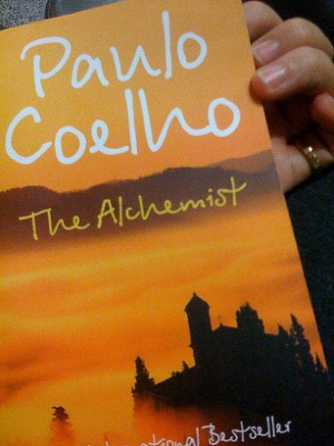

The Alchemist Webquest

Directions: Please search online for the following pieces of information. Provide 3 bullet points of information (except for the map search) and the domain name of where you found the info. Domain name is not the letters and numbers of a web address. Examples of domain names: americaneagle.com, disney.com or cnn.com. Please copy this document and rename it with your last name, first name and place it in the folder for AC ELA 7th Period.

- What is a fable?

2. What is an alchemist?

3. Copy and paste a map that shows the location of Andalusia, Spain.

4. Copy and paste a map which shows the location of the Great Pyramids in Egypt.

5. Search for the 20 most translated texts in history. Where is The Alchemist listed?

